Dental Biofilms

Biofilm Introduction
Bacteria have a slimy coating (extra cellular matrix) composed of proteins, glycoproteins and carbohydrate polymers. When in solution as single cells they are said to be in the planktonic phase and relatively easy to kill with antibiotics or by the body’s own innate or adaptive immune systems. However, infectious bacteria and viruses prefer to stick together via this slimy coating and eventually this small aggregate of cells in solution find a surface to stick to. When these cells stick together it improves their survival over just being a single cell in solution. For a variety of complex biological mechanisms these cells also want to stick. Once stuck to a surface they secrete a film (called a biofilm) that covers the surface of the bacteria kind of like a shield that make it hard for the body’s immune systems or antibiotics to attack and kill the cells (1, 3). The cells in this biofilm then safely undergo a growth and expansion process as illustrated below (2). As the biofilm grows bigger other bacteria, fungi, viruses, etc. may also stick to the biofilm and grow and divide along with the original colonizing bacteria. These new bacteria will secrete an additional layer(s) of biofilm having a different composition thus making therapy with a single drug designed to disrupt the biofilm even more difficult and less likely to succeed. This is why it is so difficult to disrupt a biofilm exposing the underlying microbe and making it even more difficult to “sterilize” the infected site. This is not a benign process.

Figure: Biofilm Growth and Spread Cycle
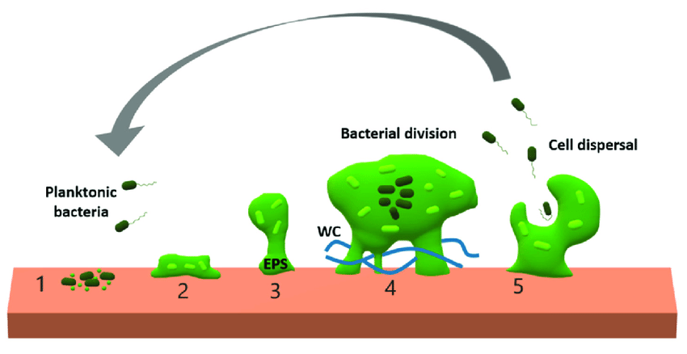

Figure description: Schematic representation of biofilm formation. 1. Planktonic bacteria establish their initial adhesion to a surface. 2. The cells start to produce an extracellular polymeric substances (EPS) matrix and divide. 3. The bacterial population grows, increasing the bacterial density, and activating quorum sensing signaling-depending processes. 4. Quorum sensing regulates the development of specialized cells and division of labor. The biofilm matrix contains extracellular enzymes and water channels (WC), that facilitate access to nutrients. 5. Activation of biofilm disruption. Some cells can disperse and initiate new biofilms. Note that biofilms can be formed by multiple species of bacteria and viruses in a cluster (2).

Even more details about biofilms
In nature biofilms almost always consist of rich mixtures of many species of bacteria, as well as fungi, algae, yeasts, protozoa, other microorganisms, debris, and corrosion products. For example, over 500 bacterial species have been identified in typical dental plaque biofilms. Biofilms are held together by sugary molecular strands, collectively termed “extracellular polymeric substances”. The cells produce these strands and are held together by these strands, allowing them to develop complex three-dimensional, resilient, attached communities. Chronic biofilm infections are a problem because the germs withing the biofilm secrete substances that cause a variety of human diseases. The biofilm then makes it difficult for immune system and antibiotic therapies to reach the germs. Thereby they tend to resist antibiotic treatments. For this reason, they are difficult to eradicate.

Disruption of the biofilm will expose the germs within making them more vulnerable to antibiotic and immune therapies. It is estimated that 75% of human microbial infections/diseases are biofilm related. Because this is such an important problem, there is an extensive research and medical literature on the subject which will not be reviewed here. Only a few examples will be given here as a “taste” of what approaches have been taken.
1. One approach is a mechanical disruption. An example of mechanical disruption is removing plaque from teeth.
2. Another approach is to present enzymes that will digest the biofilm strands and thereby expose the underlying germs to antibiotics and the immune system. Enzymes such as nattokinase and lumbrokinase have been used extensively as coatings on implants to fight biofilms (4, 5). Mucolytic enzyme N-acetylcysteine is recognized as a “powerful molecule” against biofilms (6). Other promising enzymes include proteases, plasmin, and streptokinase (7).
3. A third approach is to use powerful antibiotics that are able to penetrate the biofilms or kill the infectious organisms from the surface down (e.g. like pealing an onion leaf layer by layer.) Indeed, antibiotics such as fluoroquinolones, rifampin, and ampicillin penetrate well through the matrix (albeit sometime over days), even though they fail to eradicate 100% of biofilm bacteria. Moreover, even in the case of compounds slowly diffusing within biofilms, most antibiotics ultimately reach all biofilm bacteria. The germs that are not killed develop some resistance to the antibiotic thereby complicating further treatment (8). Another approach is to use a very small molecule that would not have any trouble diffusing into and through the biofilm to get at the infectious organisms or even react and decompose the biofilm. Such an example of this would be nitric oxide (NO). Nitric oxide in appropriate formulations has been used to treat wound biofilms and nasal sinusitis (9). This later treatment is now being developed and sold as a nasal spray (10). The company claims it has human data showing its nasal spray can kill 99% of covid germs in the nose and consequently reduce the viral infection burden.

Despite all this research and the many products on the market by many companies the biofilm area is wide open and ready for a disruptive technology or pharmaceutical therapy to provide a general solution to treating biofilms. For the purpose of this project, we will focus on dental biofilms. The proposed project below focuses on two approaches – Mechanical disruption and a combination of mechanical disruption together with a triggered release of an antimicrobial agent.

Project Objective: To evaluate the market potential for two approaches for preventing and/or mitigating biofilms on teeth and between teeth and the surrounding gums.

Dental Market Information
The global dental market is estimated to reach US$40.9 billion in 2025 with a compounded annual growth rate (CAGR) of 5.59% (2018-2025). The increase in occurrence of oral disorders such as periodontitis, gingivitis, tooth decay, denture irritation, bleeding gums, and bad breath contributes to the demand. There are 22.3 M dental procedures conducted annually in the US. The market size is huge with $16.5B for just root canal procedures. Locations for oral biofilm therapies include plaques, dentures and bridges, implants, root canal infections. Potentially fatal diseases associated with oral biofilms include aspiration-pneumonia, chronic obstructive pulmonary disease and arterial plaques.

Alfred Mann Institute
The Alfred Mann Institute at USC has had an interest in dental biofilms for many years. It is clearly an area of significant market interest. Initially it focused on wound healing, prosthetic implants, and central line catheter related biofilms. As the program progressed it focused on dental biofilms. Two main approaches were considered.
1. The Hypothesis: Disruption of the biofilms with variously formulated nanoparticles that can be triggered to change size when inside the biofilm. The small size of the nanoparticle would enable it to imbed itself into the biofilm at various depths. Then when the particle is triggered to change size it would disrupt the matrix making it easier for therapy diffuse in and get access to the infectious organisms. The idea then would be to use temperature, pH, ionic concentration or other easy to administer triggering agents to induce the size change on “command”. This particular approach probably would be considered as a “development of a medical device” by the FDA.
2. A Modified Hypothesis: Another approach is to use nanoparticles loaded with a broad-spectrum microbial within a suitable delivery formulation. The nanoparticle would be small enough to penetrate the biofilm and even enter the organism and then when triggered release the toxic payload. This would reduce the bacterial load and biofilm making additional treatment more effective. For example, one idea tried in the literature is to use silver nanoparticles. Unfortunately, silver nanoparticle was not sufficiently effective. Another approach would be to release nitric oxide (NO) inside the biofilm or bacteria (9). [Important Note: This is a different molecule than nitrous oxide (NO₂) – also known as laughing gas.] In this case it would be based on the literature suggesting that NO is toxic to bacteria and viruses. This particular approach probably would be considered as “development of a drug/device combination” by the FDA.

Of course, there could be other approaches to be uncovered during the research phase of the project. The stages of this project is basically outlined below to evaluate these two approaches and the market potential for this project. As the research phase develops there is room to change/improve the focus based on your interviews with experts in this field.

1. This project will evaluate current approaches to treating dental plaque/biofilms on teeth and gums above and below the gum line and their related infections.
2. The team will then move to interviewing KOLs to evaluate their understanding of the state of the art and their views of how to improve therapy in the future and the potential of these approaches.
3. The team will also evaluate current products on the market and companies in the area. It will also evaluate companies that provide products for this area.
4. Finally, it will propose a path forward to develop new products to address the market needs.

References:

1. Yasuhiko Irie, Bradley R. Borlee, Jennifer R. O’Connor, +3, and Matthew R. Parsek, Self-produced exopolysaccharide is a signal that stimulates biofilm formation in Pseudomonas aeruginosa, PNAS November 21, 2012, 109 (50) 20632-20636.

2. Ferriol-González, Celia & Domingo-Calap, Pilar. (2020). Phages for Biofilm Removal. Antibiotics. 9. 268. 10.3390/antibiotics9050268.
3. https://biofilm.montana.edu/biofilm-basics/what_are_biofilms.html#:~:text=Biofilm%20forms%20when%20bacteria%20adhere,even%20plant%20and%20body%20tissue.

4. Hogan S, O'Gara JP, O'Neill E. Novel Treatment of Staphylococcus aureus Device-Related Infections Using Fibrinolytic Agents. Antimicrob Agents Chemother. 2018 Jan 25;62(2):e02008-17.

5. Zapotoczna M, McCarthy H, Rudkin JK, O'Gara JP, O'Neill E. An Essential Role for Coagulase in Staphylococcus aureus Biofilm Development Reveals New Therapeutic Possibilities for Device-Related Infections. J Infect Dis. 2015 Dec 15;212(12):1883-93.

6. Dinicola S, De Grazia S, Carlomagno G, Pintucci JP. N-acetylcysteine as powerful molecule to destroy bacterial biofilms. A systematic review. Eur Rev Med Pharmacol Sci. 2014 Oct;18(19):2942-8.

7. Hogan S, O'Gara JP, O'Neill E. Novel Treatment of Staphylococcus aureus Device-Related Infections Using Fibrinolytic Agents. Antimicrob Agents Chemother. 2018 Jan 25;62(2):e02008-17.

8. Lebeaux D, Ghigo JM, Beloin C. Biofilm-related infections: bridging the gap between clinical management and fundamental aspects of recalcitrance toward antibiotics. Microbiol Mol Biol Rev. 2014 Sep;78(3):510-43.

9. Miller CC, Rawat M, Johnson T, Av-Gay Y. Innate protection of Mycobacterium smegmatis against the antimicrobial activity of nitric oxide is provided by mycothiol. Antimicrob Agents Chemother. 2007 Sep;51(9):3364-6.

10. https://sanotize.com/

